Team: Bruen
Architecture Design:
For designing the architecture of Gogy, we selected a Model-View-Controller (MVC) architecture. This pattern is well-suited for Gogy because it provides clear separation of concerns between the user interface, business logic, and data management. Given that Gogy is an educational web application with interactive quizzes, 3D visualizations, progress tracking, and user authentication, the MVC pattern allows us to maintain modular, testable code while supporting real-time updates to the UI when users complete modules or answer quiz questions. The separation also facilitates easier maintenance and future expansion of learning modules without disrupting existing functionality. Additionally, the MVC architecture supports our need for user authentication management, browser-based caching, and efficient data management across multiple user sessions with persistent login states.

Architecture Design Diagram:
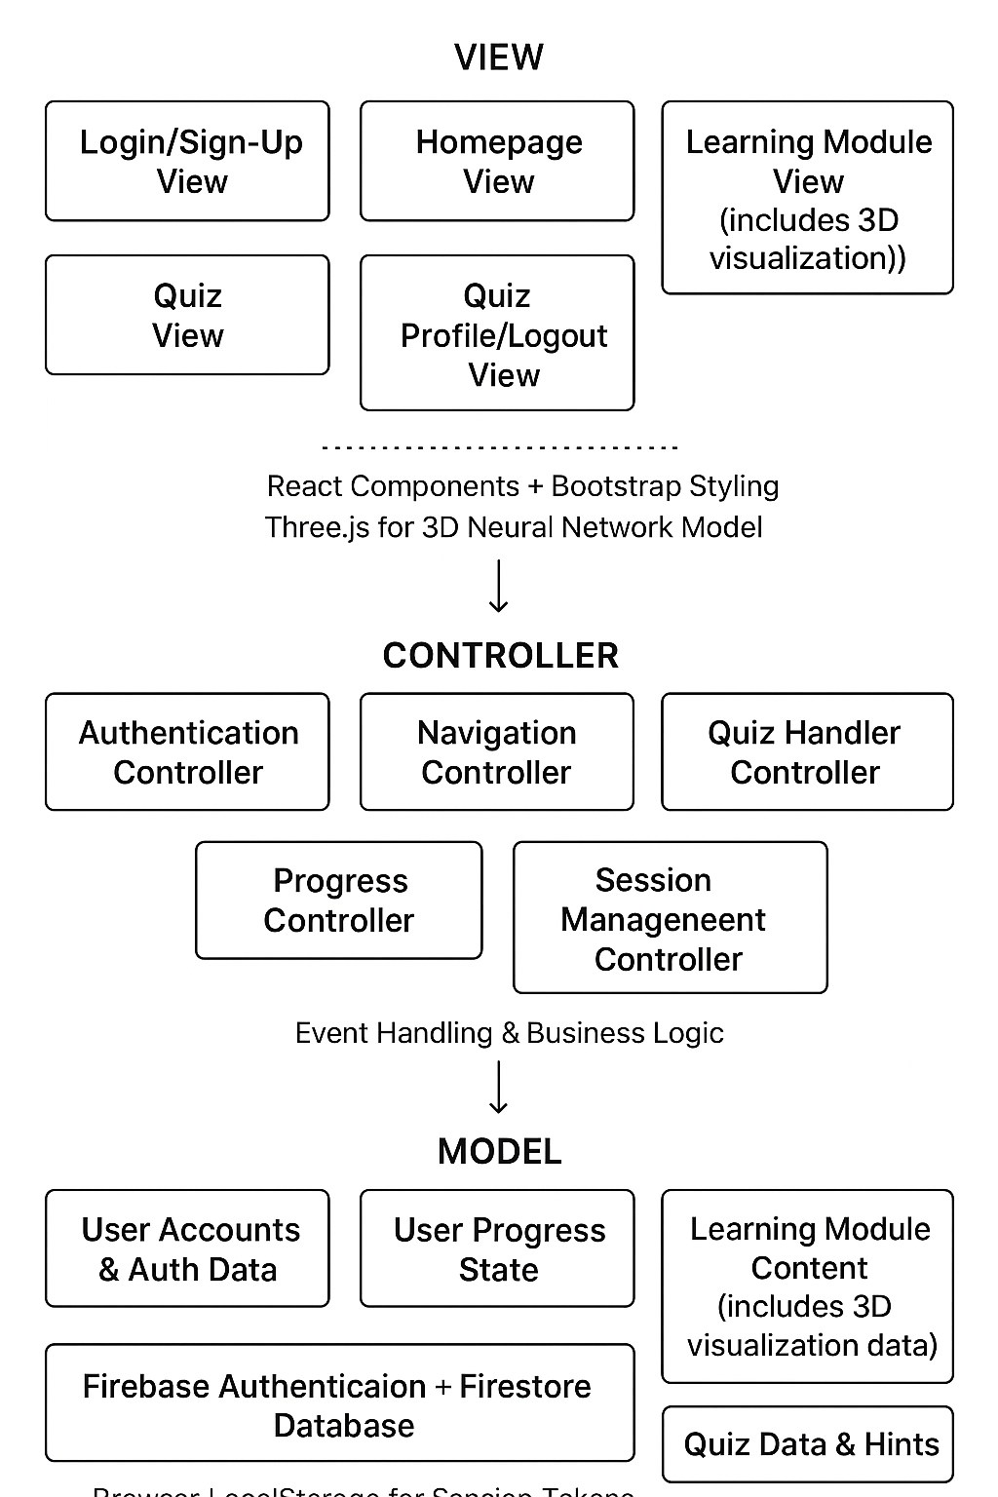

Firebase Authentication + Firestore Database
Browser LocalStorage for Session Tokens

Session Management Controller

User

User Events/ UI Updates
State Changes/ Data Requests

Design Description:
The architectural pattern consists of three components: the view, the controller, and the model.

The View Layer
The view for Gogy handles the UI of the web application. This is primarily built using React for component-based interface development and Bootstrap for responsive styling that ensures accessibility across mobile Android, Windows, Linux, and Apple devices from 2018 and later. The application features multiple views including the Login/Sign-Up View (displaying authentication forms for user registration and login), the Homepage View (displaying a menu of all learning modules and progress indicators accessible after authentication), the Learning Module View (presenting educational content in text blocks no longer than 280 characters with cited sources at the bottom of each page, and embedding the 3D visualization component), the Quiz View (displaying check-for-understanding questions with multiple choice options that appear at the end of each learning module), and the User Profile/Logout View (allowing users to manage their account and sign out).
The authentication views provide intuitive forms for user registration with email and password, as well as login functionality for returning users. Upon successful authentication, users are directed to the homepage where their personalized progress is displayed alongside a menu of at least 3 different learning modules. Each learning module focuses on AI awareness topics, with at least one module covering sensitive information that should not be submitted to LLMs. The homepage indicates whether the user has successfully completed the check-for-understanding quiz for each module next to the "open module" button.
Within the Learning Module View, users can access an embedded 3D visualization that utilizes Three.js to render a neural network model that was pre-modeled in Blender and imported into the application. This visualization includes at least 5 interactive buttons that allow users to explore the deep learning process spatially and understand how queries are processed by large language models. The 3D visualization is integrated directly into the learning module content to provide contextual understanding of AI concepts. Any user interaction—such as signing up, logging in, logging out, opening a learning module, interacting with the 3D visualization, selecting a quiz answer, navigating between modules, or viewing hints—triggers events that are sent to the controller for processing. The view layer adheres to WCAG 2.1 accessibility standards to ensure the interface is usable by all individuals.

The Controller Layer
The controller handles various events from the view layer. These events include user authentication actions (sign-up, login, and logout), navigation between learning modules, submission of quiz answers, requests for hints when questions are answered incorrectly, interaction with the 3D visualization, and tracking of learning module completion status.
The Authentication Controller manages user registration, validating email formats and password strength requirements, and communicating with Firebase Authentication to create new user accounts. It also handles login requests by verifying credentials and establishing authenticated sessions. When users log out, the controller ensures proper session termination and clears authentication tokens. The Session Management Controller maintains user session state, verifying authentication status before allowing access to protected content, and automatically refreshing authentication tokens to maintain persistent login states across browser sessions.
When a user submits an answer to a check-for-understanding question at the end of a learning module, the controller validates the response within 5 seconds and determines whether to display the correct answer with an explanation or provide the next hint from the prewritten set (cycling through at least 5 hints per question and repeating if necessary). The controller manages the business logic for quiz functionality, ensuring that users receive progressive hints and that module completion status is properly recorded and associated with their user account. Each learning module must have its quiz completed before being marked as finished on the homepage.
The controller coordinates between the view and model, notifying the view of UI updates (such as displaying quiz feedback, updating module completion indicators on the homepage, or showing authentication success/error messages) and instructing the model to persist state changes. The controller implements caching strategies to optimize loading times and ensures the application can handle up to 5,000 concurrent users 95% of the time.

The Model Layer
The model for Gogy manages all application data, including user account information, authentication credentials, learning module content (including embedded 3D visualization data), quiz questions and answers, hint sets, user progress tracking, and completion status for each learning module. The model utilizes Firebase Authentication for secure user account management, handling user registration, login credential verification, and session token generation. User-specific data, including progress and quiz completion status for each learning module, is stored in Firebase Firestore, a cloud-based NoSQL database that provides real-time synchronization and allows users to access their progress from any device.
Authentication tokens are cached in browser LocalStorage to maintain persistent login sessions, reducing the need for repeated authentication while still notifying users about cookie usage per security requirements. For users who choose not to create an account, the application maintains backward compatibility by storing progress locally in the browser using LocalStorage, though this data will not sync across devices.
Learning module content is structured to include properly cited sources at the bottom of each page, with at least one learning module focusing on sensitive information that should not be submitted to LLMs. The application includes at least 3 different learning modules covering various AI awareness topics, and each module concludes with a check-for-understanding quiz. The model maintains data structures in Firestore for quiz questions, ensuring each quiz contains at least 5 questions with at least 5 hints per question. When the controller requests data updates—such as marking a learning module as completed after its quiz is finished, recording a quiz attempt, or updating user authentication status—the model persists these changes to Firebase and notifies the view controller of any necessary UI updates. This communication enables real-time progress tracking across devices and ensures the homepage accurately reflects which learning modules have been completed for authenticated users.
The model also manages the 3D visualization data that is embedded within learning modules, providing information about the neural network structure and the processes that occur when queries are submitted to large language models. This data includes the 3D model assets, interactive button configurations, and explanatory content that integrates with the learning module material. User account data in Firebase includes email addresses (used as unique identifiers), hashed passwords (managed securely by Firebase Authentication), and user profile information. This data-driven approach with cloud storage ensures consistency across the application, enables multi-device access for authenticated users, maintains a clear record of which learning modules have been completed, and maintains clear separation from presentation and business logic concerns.

Technology Stack Summary
View Layer:
- React (UI components)
- Bootstrap (responsive styling)
- Three.js (3D visualization)
- HTML5/CSS3
Controller Layer:
- JavaScript/React event handlers
- Custom routing logic
- Business logic for quiz validation and hint management
- Authentication flow management
- Session management and token refresh logic
Model Layer:
- Firebase Authentication (user account management)
- Firebase Firestore (cloud database for user progress and data)
- Browser LocalStorage API (session tokens and offline progress)
- JSON data structures
- Client-side state management
Additional Considerations:
- Browser caching for performance optimization
- WCAG 2.1 compliance for accessibility
- Cross-platform compatibility (mobile and desktop)
- Scalability for 5,000 concurrent users
- Secure password hashing and authentication token management
- Cookie notifications for GDPR compliance

